**1st Question**

<!DOCTYPE html>

<head>

    <title>

        My First HTML Page

    </title>

</head>

<body>

    <h1> Shraddha C S Atreya</h1>

    <p>Good afternoon! My hobbies include dancing, singing.

       I also love to play sports and read a book during my free time.

       I also enjoy hanging out with my friends and love to hike sometimes. </p>

    <hr>

    <br>

</body>

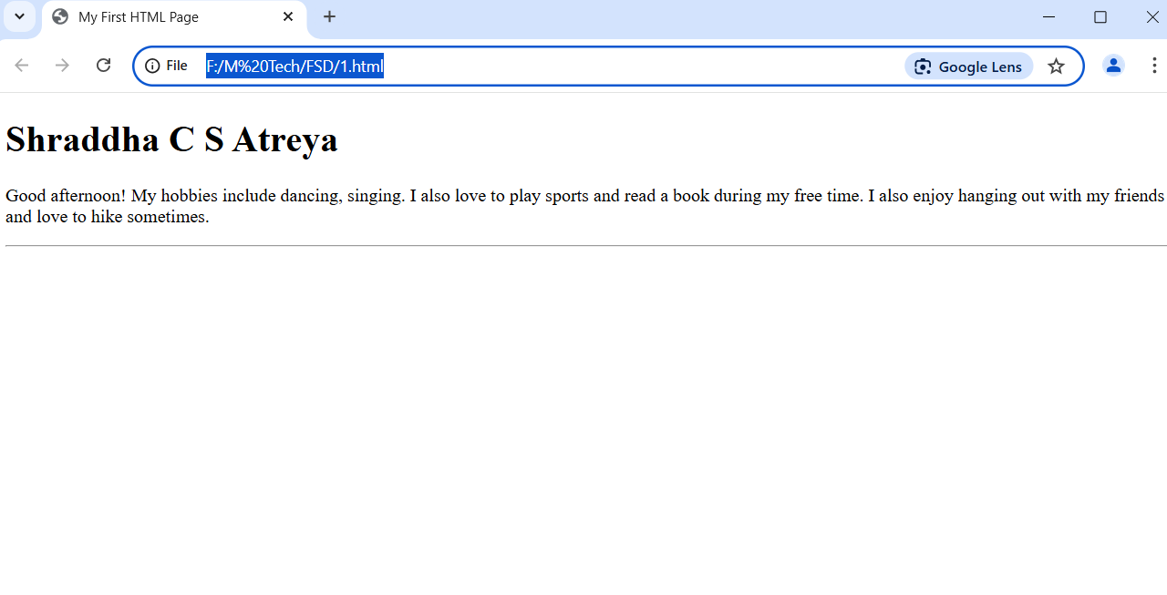

**2ND Question**

<!DOCTYPE html>

<head>

    <title>

        Second assignment

    </title>

</head>

<body>

    <h1> An unordered list of my favourite fruits</h1>

    <ul>

        <li> Mango</li>

        <li> Orange</li>

        <li> Grapes</li>

    </ul>

    <br>

    <ol>

        <li> URI - Th Surgical Strike</li>

        <li> Kantara</li>

        <li> Yeh Jawani Hai Deewani </li>

    </ol>

    <br>

    <a href="https://www.youtube.com/watch?v=ga1PMLM0Op4" target="_blank" rel="noopener noreferrer"> Link to my favourite movie</a>

</body>

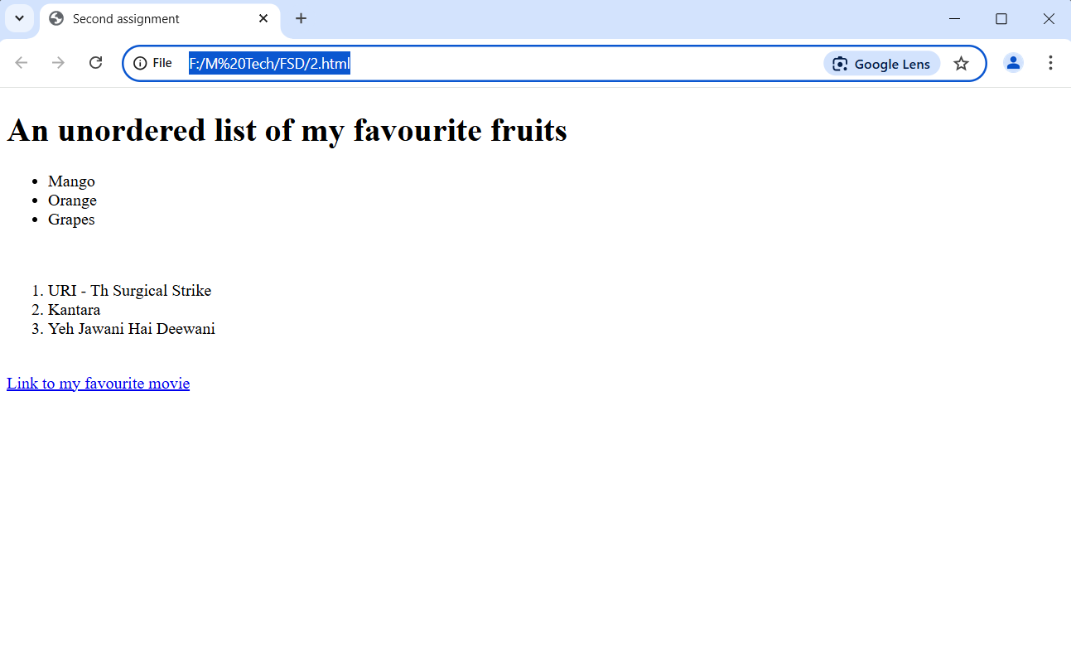

**3rd assignment**

<!DOCTYPE html>

<html>

<head>

    <title>HTML Image and Table Example</title>

    <style>

        body {

            font-family: Arial, sans-serif;

            margin: 20px;

        }

        .container {

            max-width: 800px;

            margin: 0 auto;

        }

        img {

            max-width: 100%;

            border-radius: 8px;

            margin-bottom: 20px;

        }

        table {

            width: 100%;

            border-collapse: collapse;

            margin-top: 20px;

        }

        th, td {

            padding: 12px;

            text-align: left;

            border: 1px solid #ddd;

        }

        th {

            background-color: #f2f2f2;

            font-weight: bold;

        }

        tr:nth-child(even) {

            background-color: #f9f9f9;

        }

        tr:hover {

            background-color: #f1f1f1;

        }

        h2 {

            color: #333;

            margin-top: 30px;

        }

    </style>

</head>

<body>

    <div class="container">

        <h2>Image Example</h2>

        <img src="F:\M Tech\FSD\2017-03-24-21-20-12.jpg" alt="Placeholder Image">

        <h2>Student Information Table</h2>

        <table>

            <thead>

                <tr>

                    <th>Student Name</th>

                    <th>Age</th>

                    <th>Favorite Subject</th>

                </tr>

            </thead>

            <tbody>

                <tr>

                    <td>Shraddha C S Atreya</td>

                    <td>22</td>

                    <td>Mathematics</td>

                </tr>

                <tr>

                    <td>Prajna S</td>

                    <td>28</td>

                    <td>Finance</td>

                </tr>

                <tr>

                    <td>Aadrita</td>

                    <td>08</td>

                    <td>Kannada</td>

                </tr>

            </tbody>

        </table>

    </div>

</body>

</html>

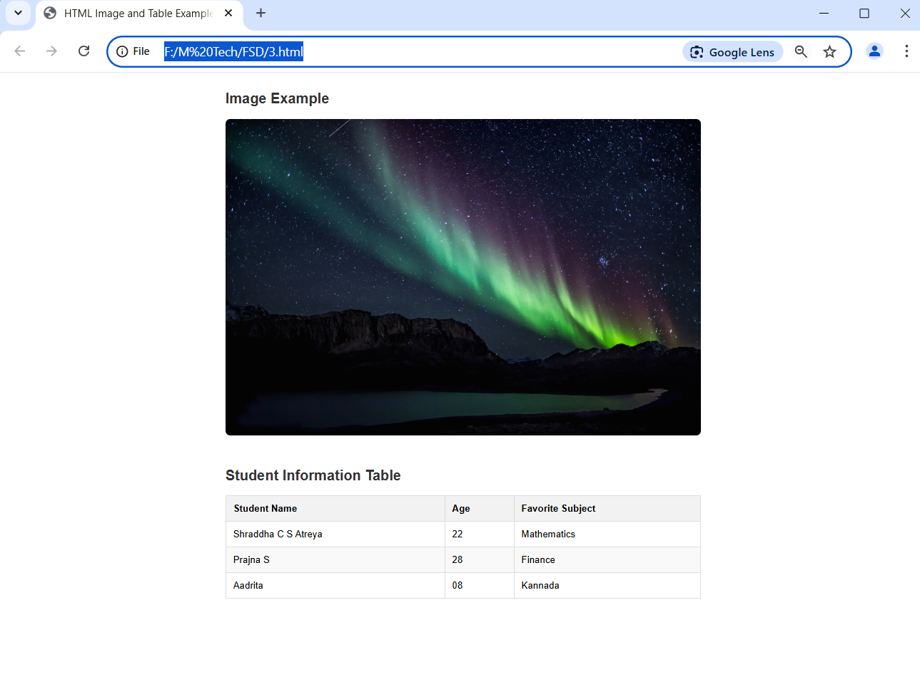

**4th assignment**

<!DOCTYPE html>

<html>

<head>

    <title>Introduction to CSS (Internal CSS)</title>

    <style>

        /* Internal CSS styling */

        h1 {

            background-color: lightblue;

            color: darkblue;

            font-size: 30px;

            padding: 15px;

            margin-bottom: 20px;

            border-radius: 5px;

        }

        p {

            font-family: Arial;

            text-align: justify;

            line-height: 1.5;

            margin: 20px;

            padding: 10px;

        }

    </style>

</head>

<body>

    <h1> AURORAS </h1>

    <p>An aurora is a natural light display that shimmers in the sky. Blue, red, yellow, green, and orange lights shift gently and change shape like softly blowing curtains.

       Auroras are only visible at night, and usually only appear in lower polar regions</p>

</body>

</html>

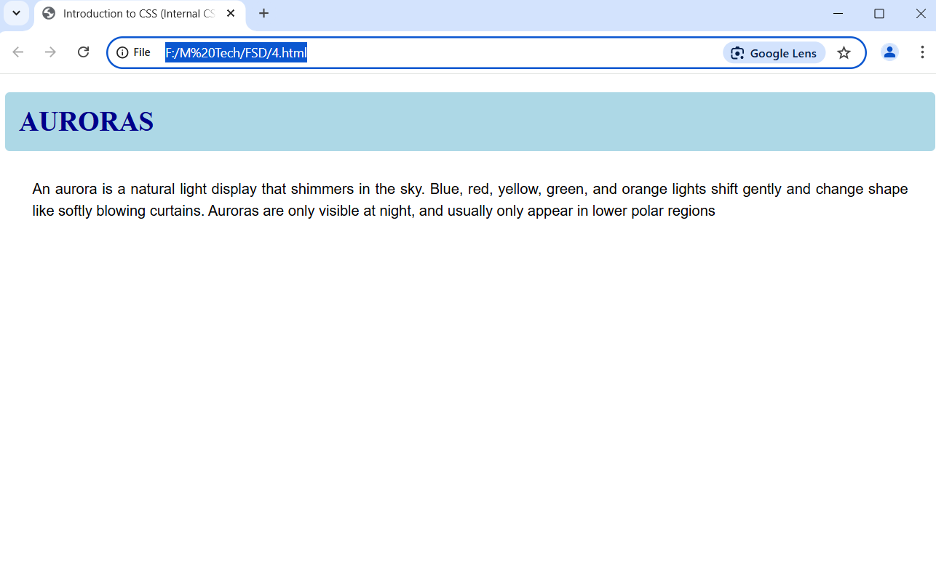

**5th assignment**

<!DOCTYPE html>

<html>

<head>

    <title>CSS Classes and IDs</title>

    <style>

        body {

            font-family: Arial, sans-serif;

            line-height: 1.6;

            margin: 20px;

        }

        /* ID Selector - using # symbol */

        #intro {

            border: 2px solid #333;

            padding: 20px;

            margin-bottom: 20px;

            border-radius: 5px;

        }

        /* Class Selector - using . symbol */

        .highlight {

            background-color: yellow;

            padding: 15px;

            border-radius: 5px;

        }

        h1 {

            color: #333;

        }

        h2 {

            margin-top: 0;

        }

        p {

            margin-bottom: 0;

        }

    </style>

</head>

<body>

    <h1>CSS Classes and IDs Example</h1>

    <div id="intro">

        <h2>Introduction Block (ID: intro)</h2>

        <p>This div element has an ID of "intro" and is styled with a border and padding.

        IDs are unique identifiers and should only be used once per page. They're

        selected in CSS using the # symbol.</p>

    </div>

    <div class="highlight">

        <h2>Highlighted Block (Class: highlight)</h2>

        <p>This div element has a class of "highlight" and is styled with a yellow background.

        Classes can be reused multiple times on a page to apply the same styling to different elements.

        They're selected in CSS using the . symbol.</p>

    </div>

    <p class="highlight" style="margin-top: 20px;">

        This paragraph also uses the "highlight" class, demonstrating how classes can be reused!

    </p>

</body>

</html>

